Category | Complete Y/N
Single Use Plastic
Water Quality
Recycling & Waste Management
Community Engagement / Action
Staff Awareness
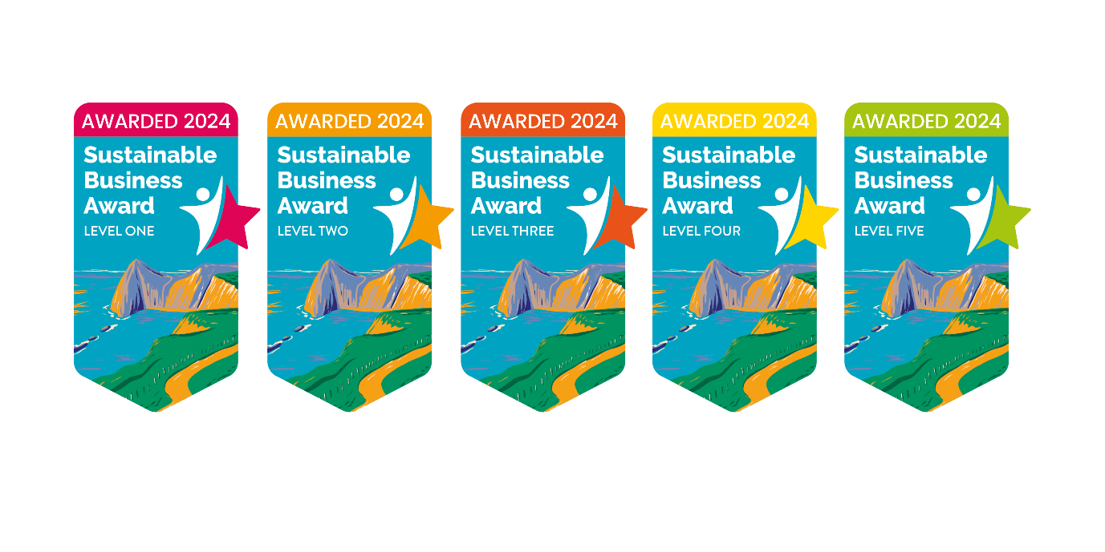
Sustainable Business Network
Award checklist

Business Name:
Category: Single Use Plastic

Issue:
Single Use Plastic (SUP) is a big problem for the environment even before it pollutes our rivers and oceans, as chemicals derived from fossil fuel production are used to make almost all plastics. Reducing even a couple of SUP items from use in your business can make a big difference to the carbon footprint of your business.
Action:  Complete 3 actions to gain an award level | Complete? | Please give us some details of how you completed the action
Complete a SUP audit
Click here to download SUP audit template

Implement a workplace SUP policy
Click here to download SUP policy template
Identify & remove five SUP items
e.g. removing single use cleaning products
Implement options to reuse plastic items (rather than alternative disposables) e.g. refilling cleaning bottles
Join the Refill campaign
Find out more about Refill here
Click here to download the app

Provide reusable cups/bottles and tap water for staff/customers
Read the Ultimate Guide to Packaging and make at least one packaging swap
Read the Ultimate Guide to Packaging here
Download and display SUP posters
We have a range of SUP posters available to download for free from the Litter Free Dorset website.

Download ‘Drinking water’ poster
Download ‘Tips to reduce SUP in the kitchen’ poster
Download ‘Tips to reduce SUP in the bathroom’ poster Download ‘Tips to reduce SUP when exploring’ poster

Contact suppliers to request less packaging/return/reusable alternatives
Sign up to the BYO campaign! Display campaign messaging encouraging customers to bring their own cup, cutlery, container, bag etc.

Category: Water Quality
Issue:
We are passionate about water quality! Dorset’s beaches are some of the most beautiful in the country (we are maybe a little biased)! To maintain such brilliant beaches, it’s important for us all to do our bit to help keep the waters clean. Actions such as only flushing the 3 P’s (paper, poo and pee), installing a water butt, as well as remembering not to feed the local seagulls can help keep our bathing water clean.
Action:  Complete 3 actions to gain an award level | Complete? | Please give us some details of how you completed the action
Display What Not to Flush messaging
Download What Not To Flush poster
Ensure there are bins available in every bathroom
Check sinks/toilets/dishwashers/washing machines for leaks and misconnections
Find advice from Wessex Water on how to check for leaks here

Install a water butt - this helps to slow the flow of rainwater helping to reduce storm overflows operating.
Install a sink strainer in your staff kitchen sink to prevent food scraps going down the drain
Pledge to always dispose of dirty wastewater from cleaning down the toilet.
Pledge to always sweep up debris during building work so it does not wash down drains.
Display a poster in your workplace about safely disposing of fats, oils and greases
Download FOGs poster here
Share the FOGs guide digitally with staff: FOGS guide (litterfreedorset.co.uk)
Food & drink businesses: Train staff members to safely dispose of kitchen fats, oils, and greases (FOG)
Food & drink businesses: Fit fat traps to dispose of all kitchen fats, oils, and greases if you are a restaurant or have a commercial kitchen
Food & drink businesses: Encourage customers to safely dispose of fats, oils, and greases (FOG) at home. Litter Free Dorset’s FOG resources can be used within your business or on your social media.

Action:  Complete 3 actions to gain an award level | Complete? | Please give us some details of how you completed the action
Provide recycling bins for customers & staff with clear instructions
Display messaging encouraging customers & staff to recycle
Provide a food waste bin for staff to use
Add one additional recycling stream e.g. soft plastics/cartons/pens/batteries
Ensure all business waste is properly separated into general waste and recycling
Find one way of reusing a waste item e.g. partner with another business
If using rubbish bags, ensure they are seagull proof
Category: Recycling & Waste Management
Issue:
Every day millions of things that could be reused or recycled end up being thrown away. Waste is everyone’s problem, and every business has a role to play in the solution. Recycling can help protect the environment while conserving natural resources. It is critical to recycle and minimize the amount of waste we are putting into the atmosphere. Doing so can help save energy, reduce landfill waste, and protect our environment.
Category: Community Engagement / Action

Action:  Complete 3 actions to gain an award level | Complete? | Please give us some details of how you completed the action
Signpost customers to the closest bin/recycling point
Organise/sponsor a community litter pick/beach clean
Find out more about how we can help organise a litter pick here

Create a social media post to highlight a sustainable change you have made
Be sure to tag us in your post and use the hashtag #MaketheChange
Facebook: Litter Free Dorset
Instagram: @litterfreedorset

Invite a business friend to join the Sustainable Business Network
Bring a business friend to the next Sustainable Business Network event
Install a public ashtray outside or in staff smoking areas
Choose to remove disposable BBQs from sale and display a #BBQsBurnMoreThanBangers poster
Download BBQ poster here

Display a ‘Don’t feed the locals’ poster to encourage the public not to feed seagulls
Download ‘Don’t Feed the Locals’ poster here
Add something to your communications (website, e-news, social) about sustainability and your commitment

Issue:
We want your businesses to be a force for good in your local community. Community engagement is an effective way to help all your customers #makethechange by providing them with sustainable choices when they use your business.

Category: Staff Awareness
Issue: Encourage everyone who works within your business to #makethechange today! Employees play a pivotal role in driving sustainability within a business, by actively engaging with your staff, you can create a thriving culture of sustainability.

Action  Complete 3 actions to gain an award level | Complete? | Please give us some details of how you completed the action
Create a mission statement that includes a commitment to the environment
Highlight reuse at your next staff event! - e.g. everyone bring a share meal
Encourage employees to reuse coffee cups and water bottles. You can promote this initiative in-office by offering company merchandise items such as travel mugs and stainless steel water bottles.
Provide smokers with stubby packs / ash trays in designated smoking areas
Promote a paperless workplace - let staff know digital is the default
Encourage sustainable transportation (have safe places to store bikes)

Conserve energy within the office (you could display a sign reminding everyone to turn the lights off as they leave)
Display our workplace poster to encourage staff to reduce, reuse and recycle!

Download ‘Reducing plastic at work’ poster

Invite everyone at work to share any innovative ideas they may have to make more sustainable changes in your business.

