Sustainable Business Network
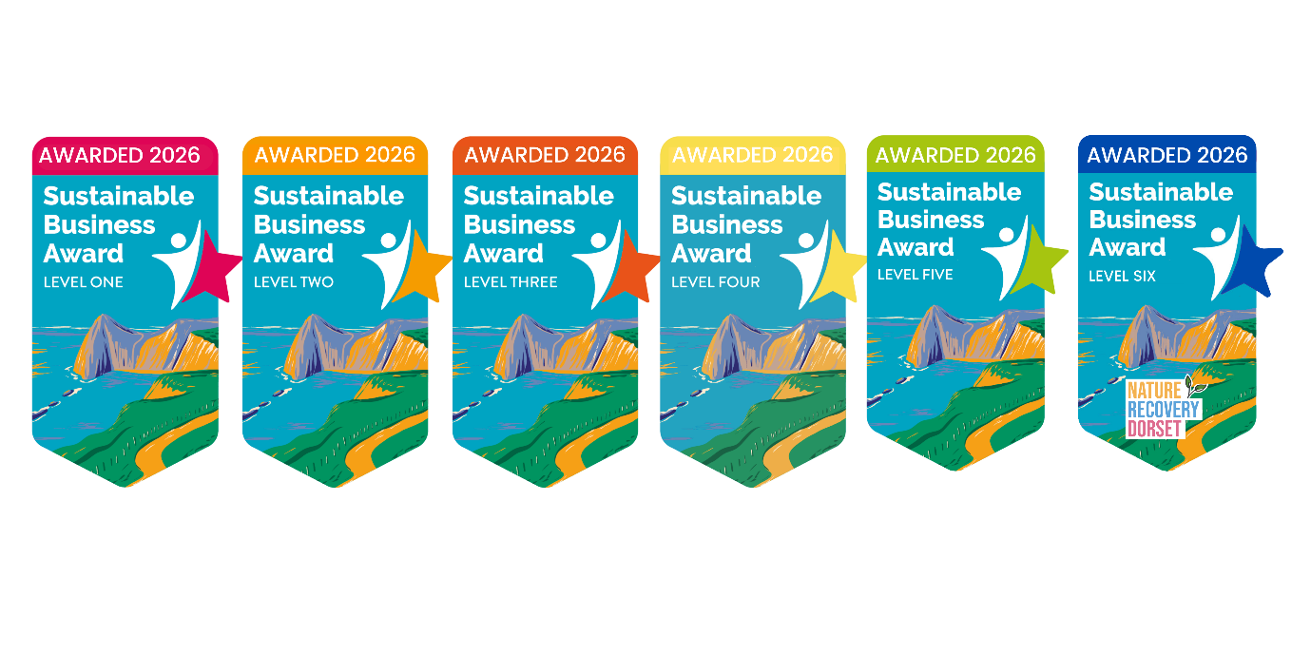Award checklist
Business Name:
Date:

We believe businesses play a key role in educating people and protecting Dorset’s natural landscapes. That’s why we are inviting Dorset businesses to take positive steps to become more sustainable and reduce their impact on the environment, by joining the Sustainable Business Network and gaining a Sustainable Business Award. Dorset businesses of any type or size can achieve a Sustainable Business Award by making small but impactful changes to the way they operate.
Simply complete this award checklist and kickstart your sustainability journey today.
There are now six levels of award, you just need to complete any three actions within a category to gain an award level.
Email your completed checklist to litterfreedorset@dorsetcouncil.gov.uk to receive your award and please do get in touch if you have any questions.
Find out more about the Sustainable Business Network here
Category: Single Use Plastic

Single Use Plastic (SUP) is a big problem for the environment even before it pollutes our rivers and oceans, as chemicals derived from fossil fuel production are used to make almost all plastics. Reducing even a couple of SUP items from use in your business can make a big difference to the carbon footprint of your business.
Action:  Complete 3 actions to gain an award level | Complete? | Please give us some details of how you completed the action
Complete a SUP audit
Click here to download SUP audit template

Implement a workplace SUP policy
Click here to download SUP policy template
Identify & remove five SUP items
e.g. removing single use cleaning products
Implement options to reuse plastic items (rather than alternative disposables) e.g. refilling cleaning bottles
Join the Refill campaign
Find out more about Refill here
Click here to download the app

Provide reusable cups/bottles and tap water for staff/customers
Read the Ultimate Guide to Packaging and make at least one packaging swap
Read the Ultimate Guide to Packaging here
Download and display SUP posters
We have a range of SUP posters available to download for free from the Litter Free Dorset website.

Download ‘Drinking water’ poster
Download ‘Tips to reduce SUP in the kitchen’ poster
Download ‘Tips to reduce SUP in the bathroom’ poster Download ‘Tips to reduce SUP when exploring’ poster

Contact suppliers to request less packaging/return/reusable alternatives
Sign up to the BYO campaign! Display campaign messaging encouraging customers to bring their own cup, cutlery, container, bag etc.

Category: Water Quality
We are passionate about water quality! Dorset’s beaches are some of the most beautiful in the country (we are maybe a little biased)! To maintain such brilliant beaches, it’s important for us all to do our bit to help keep the waters clean. Actions such as only flushing the 3 P’s (paper, poo and pee), installing a water butt, as well as remembering not to feed the local seagulls can help keep our bathing water clean.
Action:  Complete 3 actions to gain an award level | Complete? | Please give us some details of how you completed the action
Display What Not to Flush messaging
Download What Not To Flush poster
Ensure there are bins available in every bathroom
Check sinks/toilets/dishwashers/washing machines for leaks and misconnections
Find advice from Wessex Water on how to check for leaks here

Install a water butt - this helps to slow the flow of rainwater helping to reduce storm overflows operating.
Install a sink strainer in your staff kitchen sink to prevent food scraps going down the drain
Pledge to always dispose of dirty wastewater from cleaning down the toilet.
Pledge to always sweep up debris during building work so it does not wash down drains.
Display a poster in your workplace about safely disposing of fats, oils and greases
Download FOGs poster here
Share the FOGs guide digitally with staff: FOGS guide (litterfreedorset.co.uk)
Food & drink businesses: Train staff members to safely dispose of kitchen fats, oils, and greases (FOG)
Food & drink businesses: Fit fat traps to dispose of all kitchen fats, oils, and greases if you are a restaurant or have a commercial kitchen
Food & drink businesses: Encourage customers to safely dispose of fats, oils, and greases (FOG) at home. Litter Free Dorset’s FOG resources can be used within your business or on your social media.

Action:  Complete 3 actions to gain an award level | Complete? | Please give us some details of how you completed the action
Provide recycling bins for customers & staff with clear instructions
Display messaging encouraging customers & staff to recycle
Provide a food waste bin for staff to use
Add one additional recycling stream e.g. soft plastics/cartons/pens/batteries
Ensure all business waste is properly separated into general waste and recycling
Find one way of reusing a waste item e.g. partner with another business
If using rubbish bags, ensure they are seagull proof
Category: Recycling & Waste Management
Every day millions of things that could be reused or recycled end up being thrown away. Waste is everyone’s problem, and every business has a role to play in the solution. Recycling can help protect the environment while conserving natural resources. It is critical to recycle and minimize the amount of waste we are putting into the atmosphere. Doing so can help save energy, reduce landfill waste, and protect our environment.
Category: Community Engagement / Action

Action:  Complete 3 actions to gain an award level | Complete? | Please give us some details of how you completed the action
Signpost customers to the closest bin/recycling point
Organise/sponsor a community litter pick/beach clean
Find out more about how we can help organise a litter pick here

Create a social media post to highlight a sustainable change you have made
Be sure to tag us in your post and use the hashtag #MaketheChange
Facebook: Litter Free Dorset
Instagram: @litterfreedorset

Invite a business friend to join the Sustainable Business Network
Bring a business friend to the next Sustainable Business Network event
Install a public ashtray outside or in staff smoking areas
Choose to remove disposable BBQs from sale and display a #BBQsBurnMoreThanBangers poster
Download BBQ poster here

Display a ‘Don’t feed the locals’ poster to encourage the public not to feed seagulls
Download ‘Don’t Feed the Locals’ poster here
Add something to your communications (website, e-news, social) about sustainability and your commitment

We want your businesses to be a force for good in your local community. Community engagement is an effective way to help all your customers #makethechange by providing them with sustainable choices when they use your business.

Category: Staff Awareness
Encourage everyone who works within your business to #makethechange today! Employees play a pivotal role in driving sustainability within a business, by actively engaging with your staff, you can create a thriving culture of sustainability.

Action  Complete 3 actions to gain an award level | Complete? | Please give us some details of how you completed the action
Create a mission statement that includes a commitment to the environment
Highlight reuse at your next staff event! - e.g. everyone bring a share meal
Encourage employees to reuse coffee cups and water bottles. You can promote this initiative in-office by offering company merchandise items such as travel mugs and stainless steel water bottles.
Provide smokers with stubby packs / ash trays in designated smoking areas
Promote a paperless workplace - let staff know digital is the default
Encourage sustainable transportation (have safe places to store bikes)

Conserve energy within the office (you could display a sign reminding everyone to turn the lights off as they leave)
Display our workplace poster to encourage staff to reduce, reuse and recycle!

Download ‘Reducing plastic at work’ poster

Invite everyone at work to share any innovative ideas they may have to make more sustainable changes in your business.

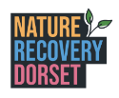

Category: Nature Recovery


No matter what size of business you have, you can get involved in making changes to help nature thrive in Dorset! Whether you’re a business with a large green space or if you have limited green space on a high street, there’s something here for everyone.
A new Local Nature Recovery Strategy (LNRS) is being created in Dorset to identify the best opportunities to restore, grow and connect nature across the county. Find out more about Dorset Local Nature Recovery Strategy
Action (Businesses without an outdoor space) | Complete? | Please give us some details of how you completed the action
Create a vertical garden – perfect for a small space!

Start recycling or composting your business’ food waste

Get involved with nature recovery by donating nature credits towards a wildlife charity. Want to support a green or blue space local to your business? Get in touch.
Do a volunteer day at a green or blue space! If you need advice help being linked up to local initiative let us know.
Celebrate events like earth day as a corporate, all employee event to raise awareness on nature, even raising money for a chosen local nature charity and improve employee wellbeing.
Investing in a few office plants can create a calm and happier environment which boosts productivity. Why not speak to your local garden centre to find out more about how different plants can transform your space. #supportlocal
Donate to plant a tree for charity – No matter the size of your donation, you’ll help create beautiful green spaces for people and wildlife to thrive.

Plant a tree for charity | National Trust
Have some hanging baskets or window boxes at your business. Plant flowers which will provide ‘bee stops’ for pollinators bypassing your business!
Post about the wildlife friendly choices you’ve made to help nature in your business. You could inspire a neighbour!

Tag @LitterFreeDorset and use the #NatureRecoveryDorset hashtag!

Action (Businesses with an outdoor space) | Complete? | Please give us some details of how you completed the action
Create one of these to help wildlife thrive in your garden: A log shelter, a pond, a bee hotel, a bat box, a hedgehog home, a hedgehog hole or a bug hotel.
Grow plants to attract butterflies and bees - Try planting a mix of colourful, scented flowers alongside a mix of herbs in a sheltered sunny spot to attract lots of pollinators to your space. Find more info here
Plant a tree! Check out the Dorset Community Tree Fund and this handy guide to plant a tree.
Plant a native hedge or a shrub garden for wildlife. Native trees provide the greatest benefits for insects, birds, small mammals, reptiles and other wildlife. Speak to your local garden centre to learn more about native plants and their benefits! #shoplocal
Reduce your mowing schedule in parts of your garden and let your grass grow long. Did you know long grass is home to all sorts of creatures, big and small? Went left to grow, the grasses will set seed, wildflowers can bloom and provide nectar, and the longer stems will create a sheltered microclimate.
Leave a wild patch to attract pollinators. When planting a pollinator-friendly garden, it's essential to include a variety of flowers that bloom at different times throughout the growing season to provide a continuous food source for pollinators. Additionally, opting for native plants can help support local pollinator populations. Ask your local garden centre for advice if needed. #shoplocal
Start collecting rainwater for watering plants – How to install a water butt | Dorset Wildlife Trust
Choose to never use chemicals or pesticides in your outdoor space. By committing to a pesticide-free and organic approach in your outdoor space, you contribute to a healthier and more sustainable environment. Encourage all employees to say no to using any chemicals in their own gardens too which will protect pollinators, improve biodiversity, promote soil health and protect human health.
Always choose peat free compost. Peat soil is a non-renewable resource and preserving rare peatlands is vital for the unique biodiversity they support, as well as for the wider environment.
Upcycle and reuse materials in the garden rather than buy new.
Provide an outdoor seating area for your staff to spend time outdoors. Spending time in nature can have a positive impact on employee health and wellbeing.

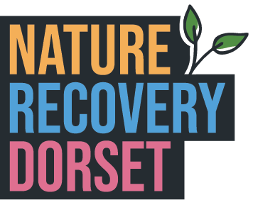

By completing the Nature Recovery category, you automatically qualify to join the Nature Recovery Network!
To showcase and celebrate all the great things happening across Dorset to support nature recovery, the Nature Recovery Dorset team are creating a map highlighting all the wonderful actions taken by landowners, farmers, businesses, schools, organisations, local community groups and the public and we want your business to be part of it!

☐ Please tick the box to give your consent for us to share your sustainable actions with the Nature Recovery team and to plot your business on the map.

Please tell us a bit more about what you’re doing for nature and why it’s important to your business:

Thanks for completing your Sustainable Business Award checklist!!
Please email your completed checklist to litterfreedorset@dorsetcouncil.gov.uk to receive your award and feel free do get in touch if you have any questions or need any advice.
Stay in touch and continue the great work by making small but impactful changes to the way your business operates.
The Litter Free Dorset team x

Please feel free to tell us about any additional sustainable changes you have made in your business, we would love to celebrate them on social media!

